Drop Required User DB’s –SQL Server.

--TSQL Script to drop required User DB’s.

-- TSQL Script to Drop required User Databases
use master
go
DECLARE @command nvarchar(max)
SET @command = ''
SELECT @command = @command
+ 'ALTER DATABASE [' + [name] + '] SET single_user with rollback immediate;'+CHAR(13)+CHAR(10)
+ 'DROP DATABASE [' + [name] +'];'+CHAR(13)+CHAR(10)
FROM [master].[sys].[databases]
where [name] in ( 'testdb1', 'testdb2', 'testdb3');

SELECT @command
EXECUTE sp_executesql @command
Before Executing the above Drop User DB’s Query:
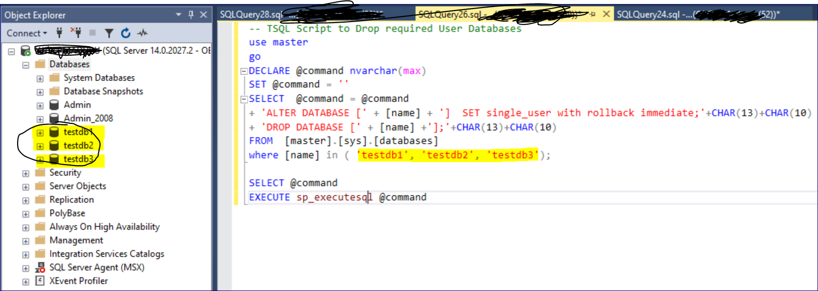

After Executing the above Drop User DB’s Query. The mentioned user DB’s will get dropped immediately.
